CMPEN417 FPGA

Final Project Report

Team: Qiaosha Zou, Cong Xu, Tania Sekhon

# Project Overview

This project is to develop a skintone-detector on FPGA board with the knowledge we learn from the class. The whole system consists 5 big modules: the controller (works as slave to the host), the fetcher (works as interface to the network), the rgb-to-ycrcb converter (converts the RGB values of a pixel to YCrCb values), the skintone-detector (comes out with the skintone score to determine if one pixel belongs to skin) and the storer (works as interface to the network).

The main challenges in this project are: 1. frequent divisions and multiplications in the converter and detector, if we want to obtain high frequency detector, we must well pipelined the divisor and multiplier; 2. handshaking between modules, because handshaking will determine if the data is valid or not and influence the timing during processing.

# Individual Module Design Report

1. Controller
2. RGB-to-YCrCb Converter

The converter takes input from fetcher and output the YCrCb values to skintone detector. The converter block diagram and its 5 pipe-line stages is shown as below:

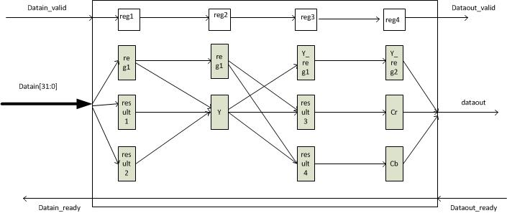

The arrows show the data flow direction.

The first input data takes 5 cycles to reach the output port, but after that, every cycle has steady output. Random testing result is shown in the following figure (5 cycles are marked with yellow lines here).

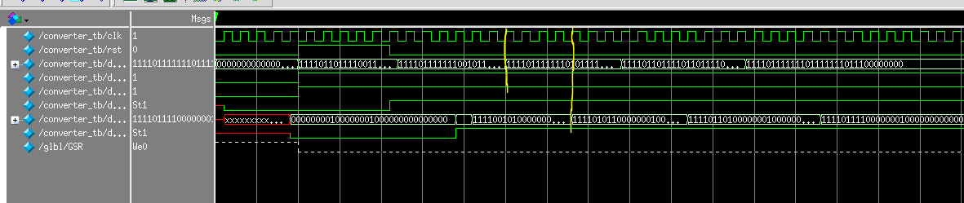

The synthesized report of the converter is shown below:

//-------------------------------------------------------------------------------------------------------

Final Register Report

Macro Statistics

# Registers : 26

Flip-Flops : 26

# Shift Registers : 41

2-bit shift register : 32

3-bit shift register : 8

4-bit shift register : 1

//--------------------------------------------------------------------------------------------------------

Timing Summary:

---------------

Speed Grade: -1

Minimum period: 5.670ns (Maximum Frequency: 176.351MHz)

Minimum input arrival time before clock: 5.305ns

Maximum output required time after clock: 0.777ns

Maximum combinational path delay: No path found

//------------------------------------------------------------------------------------------------------------

In summary, the converter module has frequency 176.351MHz.

1. Fetcher and Storer
2. Skintone Detector
3. System Wrapper

# Project Summary